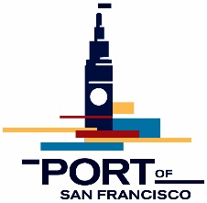

NOTICE AND AGENDA FOR A MEETING OF THE
EMBARCADERO SAFE NAVIGATION CENTER ADVISORY GROUP (ESNCAG)
Wednesday, July 26, 5:30 pm

Virtual Meeting Via Zoom

Link:  Password: | https://us06web.zoom.us/meeting/register/tZ0kcumsqzgtE9O0x5zxAsdCvIxwLgUw4KIm  146361
Dial-in | +1 669 900 6833
Meeting ID | 899 5045 3797

- Welcome, Meeting Objectives, and Updates – Rick Dickerson and Alice Rogers, ESNCAG Chair & Vice Chair (5:30pm)

- Operational Updates and Community Q&A – City staff will share data and updates and members of the public are invited to ask questions, raise concerns, and make comments for the Advisory Group to discuss. (5:40pm)
- Updates from the ESNCAG Inbox – Port staff will share updates from the ESNCAG email inbox and responses.
- Navigation Center Updates – The Department of Homelessness and Supportive Housing (HSH) and Five Keys will present data and updates from the Navigation Center.
- Police Updates – Captain Martin will share updated police incident data and any other updates from the Safety and Outreach Zone.
- Updates from the Department of Emergency Management (DEM) - A representative from DEM will provide an update on the work of the Healthy Streets Operations Center (HSOC).
- Community Meeting Updates – HSH staff will provide an update on upcoming community meetings for a new MOU for the Embarcadero SAFE Navigation Center.

Please note that times are approximate and agenda items may be taken out of order.

EMAIL NOTICE OF ADVISORY GROUP MEETINGS – If you would like to receive e-mail notification of advisory group meetings and receive agendas and meeting notes, sign up here: https://sfport.com/community. For other inquiries please contact ESNCAG@sfgov.org.

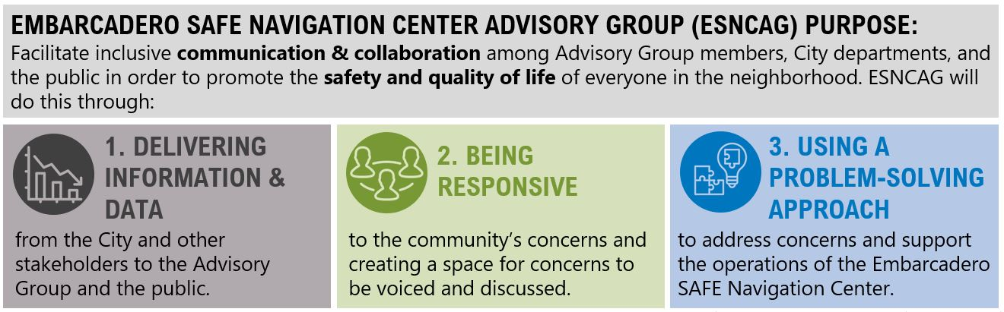

Safety Zone
Primary Outreach Zone

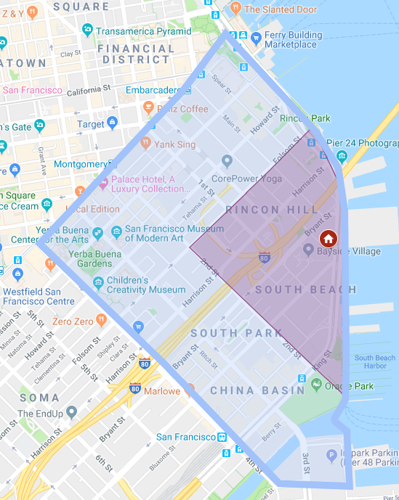
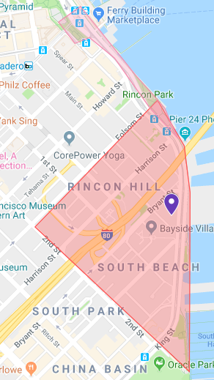

ESNCAG Virtual Meeting Protocols

During the COVID-19 pandemic, the Port of San Francisco is conducting business remotely as we comply with State of California and local health directives and orders for social distancing and staying at home. The Port is committed to ensuring that our meetings are accessible to the public, including the opportunity to participate by providing oral and written comment. The instructions below outline how members of the public can access the virtual ESNCAG meeting and provide public comment.

- How to Join
  - Go to the first page of the notice/agenda and click on the Zoom Virtual Meeting Link.
  - You can join the meeting from a desktop computer, mobile device, or telephone. Learn more about Joining a Zoom Meeting.
    - If you are calling in, but would like to access meeting materials, please use links provided in the agenda above or visit the ESNCAG meeting webpage and locate the specific meeting date.
    - We recommend that you test out your device, internet connection, and Zoom app compatibility well before attempting to join the meeting.
  - When prompted, provide your name and email address to be placed in the meeting. You will automatically be muted when joining as an attendee.

- Providing Public Comment
  - Public comment for ESNCAG virtual meetings can be provided in multiple ways.
    - Written Comments:
      - You are welcome to submit written comments to Port staff via email. Please send to esncag@sfgov.org
      - In the subject line of your email, indicate the meeting date and the topic of your comment. For an item on the agenda, please include the meeting date and item number.
    - Oral Comments:
      - Following committee discussion of each agenda item, Port staff will provide an opportunity for public comment.
      - If you want to provide oral comments on a specific agenda item, you will need to “Raise your hand” during the Zoom meeting. *If calling into the meeting from a telephone, you can use “Star (*) 9” to raise/ lower your hand.
      - Once your hand is raised and it is your turn to speak, the ESNCAG meeting facilitator will unmute you, announce your name, and you will be able to make your comment. *Depending on how you have called in, you may also need to unmute yourself.
      - After your public comment, your hand will be lowered, and you will be placed back on mute.

Language Access

English:
At the Port of San Francisco, it is our policy to provide free language assistance to Limited English Speaking (LEP) individuals upon request. We are committed to ensuring that persons with limited English proficiency are given equal access to the Port’s services, programs, public land and facilities.
For questions or assistance with language access related matters please contact:
- Port of San Francisco Language Access Liaison:
  - Jenica Liu, Business Services Supervisor
  - Email: Jenica.Liu@sfport.com
  - Telephone: (415) 274-0471
Spanish:
Nuestra política en el Puerto de San Francisco está centrada en proveer asistencia gratuita a las personas de dominio limitado del idioma inglés (LEP, siglas en inglés) que la pidan. Estamos comprometidos a asegurar que las personas de dominio limitado del idioma inglés tengan el mismo acceso a servicios, programas, instalaciones y terrenos públicos del Puerto.

Si tiene preguntas o si necesita ayuda con asuntos relacionados con el acceso a idioma por favor, póngase en contacto con:
Agente de Acceso a Idiomas del Puerto de San Francisco
Jenica Liu, Supervisor de Servicios Empresariales
Correo electrónico: Jenica.Liu@sfport.com
Teléfono: (415) 274-0471

Chinese:
三藩市港務局（Port of San Francisco）當局的政策規定，須應請求向英語能力有限（LEP）人士提供免費的語言協助。 本局致力於確保英語能力有限人士能平等使用港務局（Port）的各項服務、計劃、公眾用地及設施。

如有疑問或需要提供語言服務相關事宜的協助，請聯絡:

• 三藩市港務局語言服務聯絡員:
o Jenica Liu, 商務主管
o 電郵: Jenica.Liu@sfport.com

Filipino:
Sa Port ng San Francisco, patakaran naming magbigay ng libreng tulong sa wika sa mga taong Limitado ang Pagsasalita sa Ingles (Limited English Proficient- LEP). May pananagutan kaming siguraduhin na lahat nakukuha rin ang mga tao na limitado ang pagsasalita sa Ingles ng mga kaparehong serbisyo, programa, pampublikong lupa at pasilidad ng Port na kagaya ng iba.
Para sa mga katanugan o sa tulong sa mga bagay na kaugnay sa pag-access sa wika puwedeng kontakin si:
- Port of San Francisco Language Access Liaison:
  - Jenica Liu, Business Services Supervisor
  - Email: Jenica.Liu@sfport.com
  - Telepono: (415) 274-0471
ACCESSIBLE MEETING INFORMATION
Accessible meeting information policy: In order to assist the City’s efforts to accommodate persons with severe allergies, environmental illness, multiple chemical sensitivity or related disabilities, attendees at public meetings are reminded that other attendees may be sensitive to various chemical based products. Please help the City to accommodate these individuals. A sign language interpreter and alternative format copies of meeting agendas and other materials can be provided upon request made at least 72 hours in advance of any scheduled meeting. Contact Wendy Proctor, Port’s ADA Coordinator, at 274-0592. The Port’s TTY number is (415) 274-0587.

